DC Energy Meter

- Requirements:

A device to monitor Voltage and Current bidirectionally and store the data in a SD Card. Minimum specs: 100V 50~100A.

- Initial Solution:
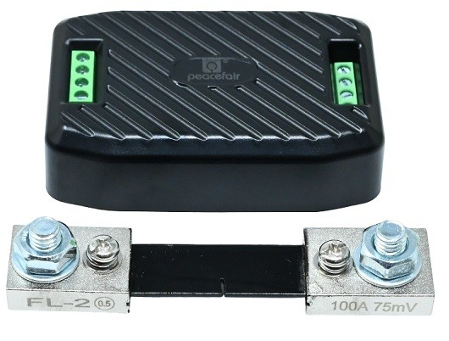
IMPORTED FROM CHINA BY robu.in


Peacefair PZEM-017 with 100A shunt resistor
- 0.05 - 300V
- 0.02 – 300A
- 1% accuracy

This system acts as a standalone DC energy logger and wireless dashboard. It measures high-power DC voltage and heavy current via an external $100\text{A}/75\text{mV}$ brass shunt using a PZEM-017 module. The PZEM-017 transmits measurement data via Modbus RTU over an RS485 bus, which an auto-flow converter translates into $3.3\text{V}$ serial signals. The ESP32-C3 SuperMini processes these metrics, simultaneously writing time-stamped .CSV logs onto a MicroSD card and hosting a local Wi-Fi web server to display real-time graphical graphs on a laptop or phone.

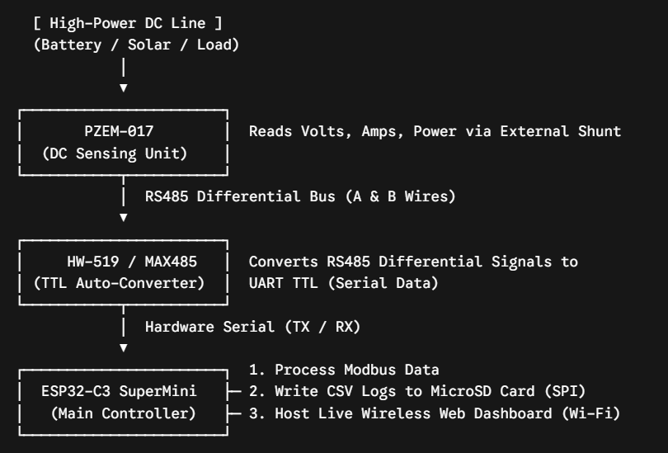
- Problem:
Imported from China by robu.in and all variants are sold out.
Kind-of expensive (900~5000+)
Requires TTL to RS485 converter to communicate through UART

- Proposed Solution:
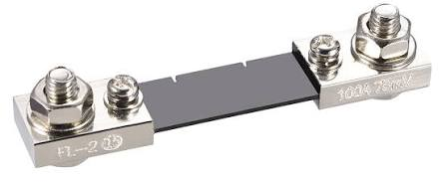
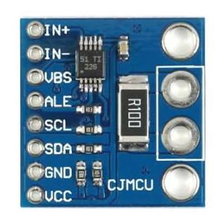

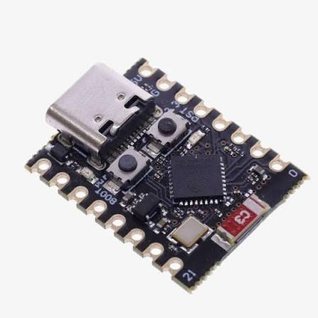

This system serves as a standalone DC energy logger and wireless dashboard. High system current passes through an external $100\text{A}/75\text{mV}$ brass shunt, generating a millivolt drop measured by an INA226 module (with its onboard resistor removed). A $0.1\%$ precision voltage divider scales pack voltages ($0\text{--}60\text{V}$) down to safe levels for the INA226. The INA226 sends 16-bit measurements over $I^{2}C$ to an ESP32-C3 SuperMini, which scales the values back, writes timestamped .CSV logs to a MicroSD card via SPI, and hosts a Wi-Fi server displaying real-time graphical data on a laptop or phone.

